1. 
2. 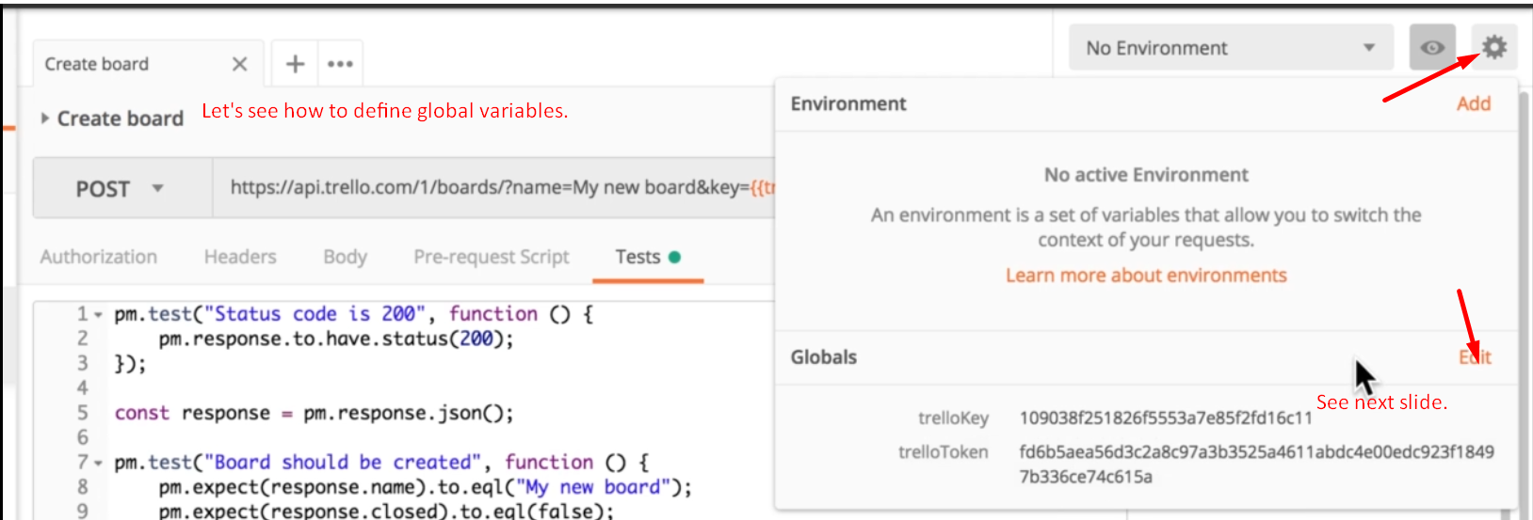
3. 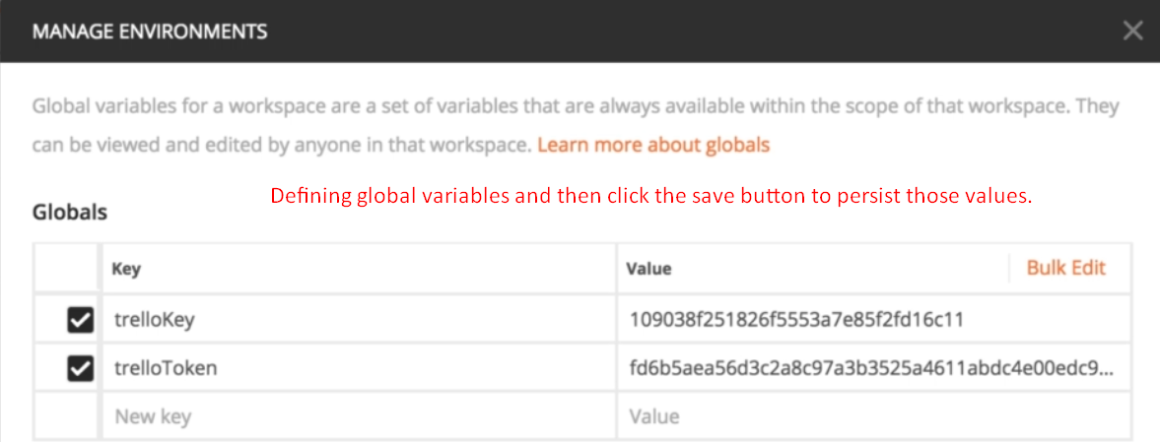
4. 
5. 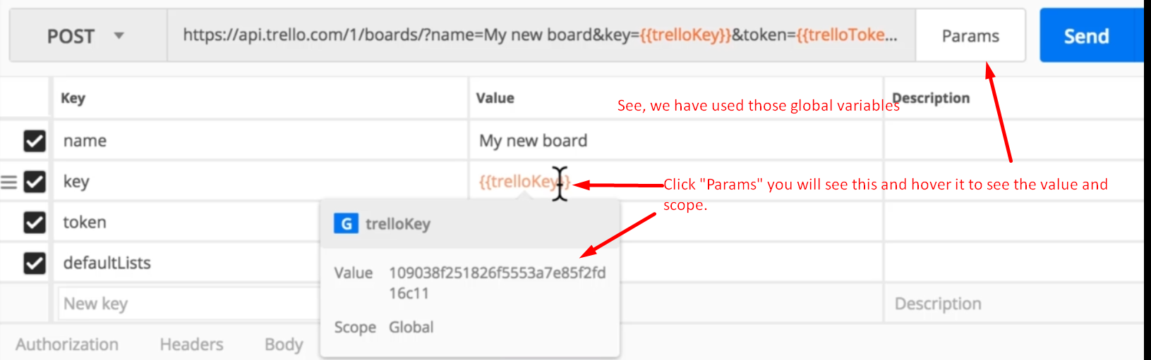
6. If you don’t see value on hovering, it means we didn’t either create or save them yet.
7. 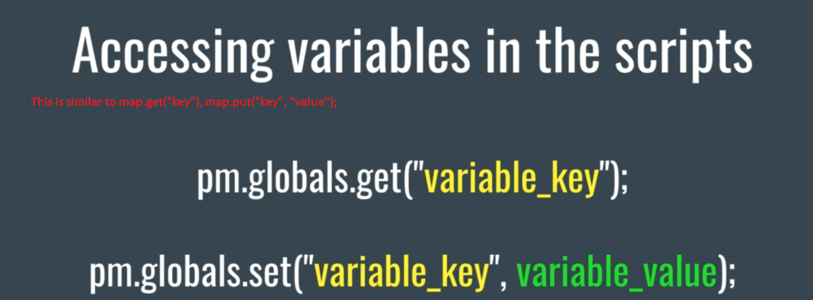
8. 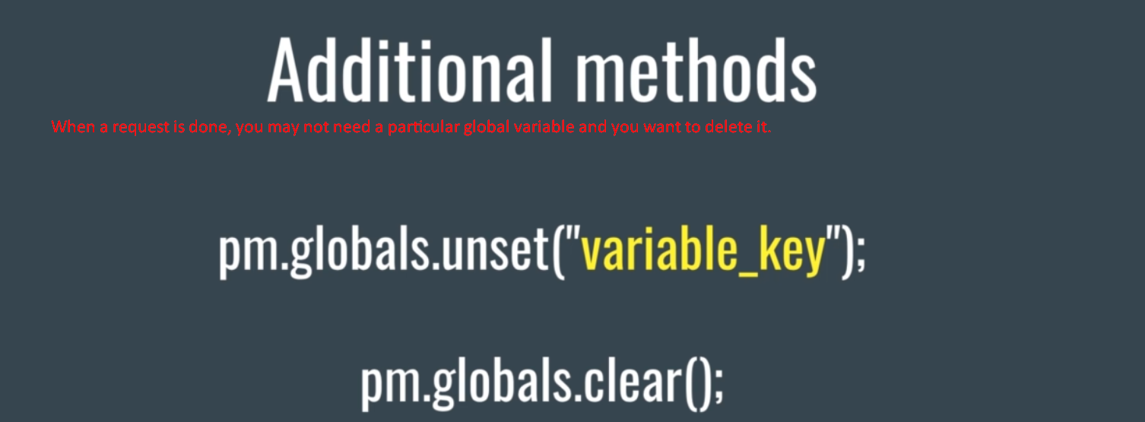
9. Start from 3:45